Director's Message

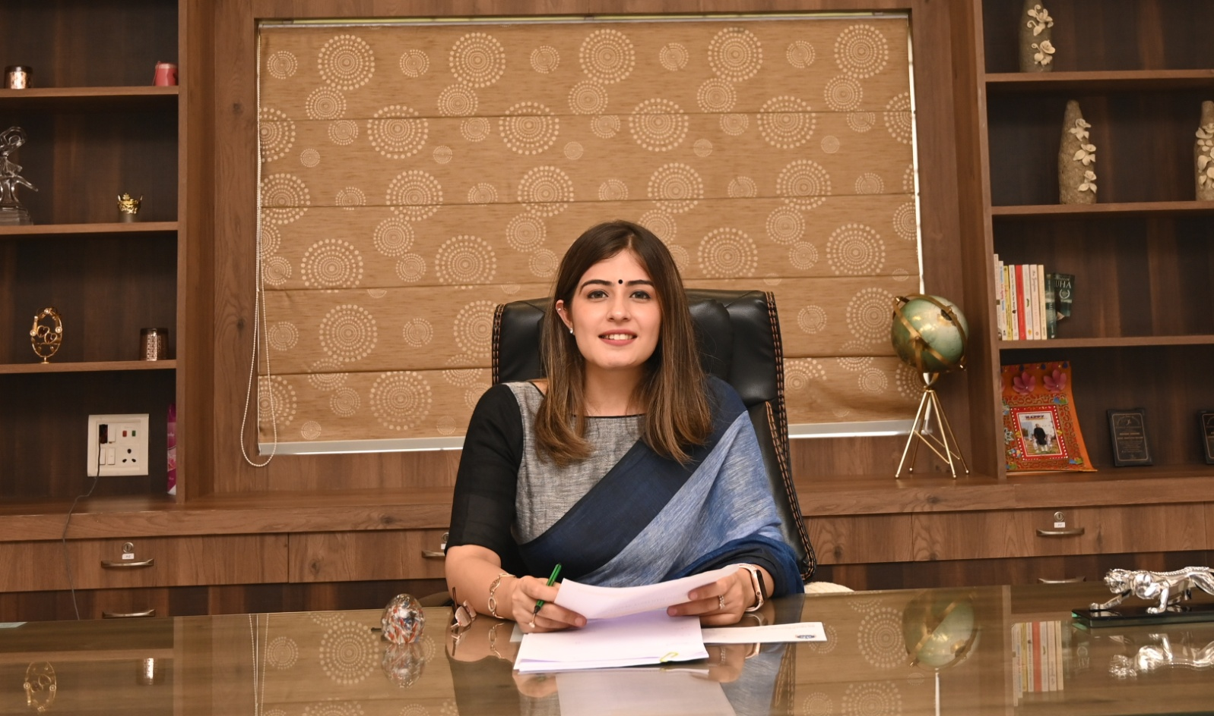

Mrs. PALAK GROVER

Director – Academics
I am delighted to welcome you to Ajay Satya Prakash Public School.
Our Core Aspiration is to provide an Educational Excellence, in that every student makes a positive difference during the time with us. In expecting Excellence we ensure that children enjoy school in a happy, safe and secure atmosphere designed to fulfill their potential. We also strive to provide a caring, supportive and challenging environment to the children, in which they can grow and flourish to the esteemed heights.
Our School’s curriculum is carefully framed in such a way to deliver the quality education to the children. To meet the needs of high standard of education, we incorporates the best and innovative practices of Education and Technology together. Also we knew about the role of teacher in the welfare and progress of children. At ASPPS, we recruited highly qualified, intrinsically motivated, dynamic professionals who ensures the development of the child academically and personally and to strengthen our vision and mission.
Ajay Satya Prakash Public School offers an extraordinary opportunity both in Scholastic and Co-Scholastic areas. We have a comprehensive array of Co-Scholastic activities that encourage our children to develop their talents.
" The whole purpose of Education is to turn mirrors into windows"
– Sydney J. Harris.
Children are the most precious asset for us. We expect all the children to do their role as best as they can and aspire to excel in diverse fields. Also we would like to have a mutual support and partnership from parents and we request the parents to actively participate in their child’s school activities.
I strongly believe that true education should instill knowledge, creativity, tradition and Culture among the children and we Directors along with faculties work together to motivate the children to perform well in every walk of their journey towards noble citizens of tomorrow.
Let us pray Lord Almighty to be with us forever and with his blessings I envisage the glorious future of Ajay Satya Prakash Public School.
Thank you for your interest in Ajay Satya Prakash Public School. We eagerly look forward to meeting you soon.

